T.C.
YILDIZ TECHNICAL UNIVERSITY
NAVAL ARCHITECTURE AND MARITIME FACULTY
DEPARTMENT OF NAVAL ARCHITECTURE AND MARINE ENGINEERING

GRADUATION PROJECT TITLE


Name SURNAME

Supervisor
Prof. Dr. Name SURNAME

June, 2026
ACKNOWLEDGEMENTS
I would like to express my sincere thanks to my advisor Asst. Prof. Dr. Serdar Turgut İNCE, who did not spare his support and knowledge at every stage of this study. In addition, I am grateful to Assoc. Prof. Dr. Asım Sinan KARAKURT, who enlightened and guided me with his help throughout the process. I would like to thank all my professors for sharing their knowledge and experience with me. I would also like to express my gratitude to my family and friends who supported me during my work.
Name SURNAME
Signature

“This study is supported by ... TÜBİTAK 2209-A".
(If there is no support, this text should be deleted!)

TABLE OF CONTENTS

ACKNOWLEDGEMENTS ii
TABLE OF CONTENTS iii
LIST OF SYMBOLS iv
LIST OF ABBREVIATIONS v
LIST OF FIGURES vi
LIST OF TABLES vii
ABSTRACT viii
ÖZET ix
1 INTRODUCTION 1
1.1 Purpose of the Thesis 1
1.2 Literature Review 1
2 CHAPTER HEADING 5
2.1 Sub-Title 5
3 CHAPTER HEADING 6
3.1 Sub-Title 6
4 CONCLUSION 7
4.1 Conclusion 7
REFERENCES 8
CURRICULM VITAE 10

LIST OF SYMBOLS

Cb Block coefficient
Fn Froude number
RT Total resistance (N)
Δ Displacement (tons)

LIST OF ABBREVIATIONS

BEM Boundary Elements Method
CFD Computational Fluid Dynamics
EHP Effective Horsepower
FEM Finite Element Method
FoS Coefficient of Safety
ITTC International Towing Tank Conference
LWT Light Weight
PMM Planar Motion Mechanism
RANSE Reynolds-Averaged Navier-Stokes Equations
LIST OF FIGURES

Figure 1.1 The first letters of the figure titles should be capitalized and the other letters should be lowercase. It should be centered under the figure 3
Figure 1.2 If you want the shapes you add to appear when you use the update table command to the shape table, you need to select the shape caption style as "Caption". 4

LIST OF TABLES

Table 1.1 If you want your tables to appear in the Table list when you say Update field, you must select the style of the table headers as "Tables" 2
Table 1.2 If you want your tables to appear in the Table list when you say Update field, you must select the style of the table headers as "Tables" 2

ABSTRACT

Graduation Project Title
Name SURNAME
Undergraduate Graduation Project
Naval Architecture and Maritime Faculty
Department of Naval Architecture and Marine Engineering
(Students who use it for research project or other project courses must change the title of "Undergraduate Graduation Project".)

Advisor:
Prof. Dr. Name SURNAME
The abstract should be a short but comprehensive summary of your work. It should include the following elements:
- Purpose and importance of the study: Explain why the topic is addressed and what problem it solves.
- Methods used: Summarize the methods and approaches used in the research process.
- Key findings: Present the main takeaways to the reader by summarizing the key conclusions obtained.
- Conclusion and contribution: Indicate the contribution of your study to the literature or field of practice and how the results obtained are evaluated.
The abstract should be between 150-250 words and include 3-5 keywords.
Keywords: Key, Word

ÖZET

Bitirme Çalışması Başlığı
Adı SOYADI
Lisans Bitirme Çalışması
(Araştırma projesi veya başka proje dersleri için kullanan öğrenciler “Lisans Bitirme Çalışması” başlığını mutlaka değiştirmelidir.)
Gemi İnşaatı ve Denizcilik Fakültesi
Gemi İnşaatı ve Gemi Makineleri Mühendisliği Bölümü
Danışman:
Prof. Dr. Adı SOYADI
Özet, çalışmanızın kısa fakat kapsamlı bir özeti olmalıdır. Aşağıdaki unsurları içermelidir:
- Çalışmanın amacı ve önemi: Konunun neden ele alındığını ve hangi soruna çözüm getirdiğini açıklayın.
- Kullanılan yöntemler: Araştırma sürecinde kullanılan yöntemleri ve yaklaşımları özetleyin.
- Başlıca bulgular: Elde edilen temel sonuçları özetleyerek okuyucuya ana çıkarımları sunun.
- Sonuç ve katkı: Çalışmanızın literatüre veya uygulama alanına olan katkısını ve elde edilen sonuçların nasıl değerlendirildiğini belirtin.
Özet 150-250 kelime arasında olmalı ve 3-5 anahtar kelime içermelidir.
Anahtar Kelimeler: Anahtar, Kelime

- INTRODUCTION

Purpose of the Graduation Project
In this section, you should clearly state the main purpose of your study, the problem it aims to solve, and its importance. By explaining the place and contribution of your work in the scientific or technical field, you should highlight why this topic is being addressed. Also, state your research questions or hypotheses, articulating which questions you are looking for answers to.

Literature Review
In this section, you should examine the previous studies on the topic in detail and explain its connection to your graduation project. When conducting a literature review, you should consider the following points:
- Summarizing previous studies and highlighting important findings.
- Explanation of the main theories and approaches to the subject.
- Identifying gaps in existing studies and explaining how these deficiencies will be addressed by your work.
- Conducting a systematic presentation by organizing the literature chronologically, thematically or methodologically.
- You should use the sources by citing them in accordance with academic rules and show that your study is based on a scientific basis.

As shown in Table 1.1, the efficiency values of marine propellers increase with speed. Table 1.2 compares the calculated resistance coefficients for different propeller geometries, and the most suitable design has been identified. The obtained results are consistent with the data reported in the literature and support the model validation.

Table 1.1 If you want your tables to appear in the Table list when you say Update field, you must select the style of the table headers as "Tables"
Step # | Explanation
1 | Thrust Force (T) [N]
2 | Calculated Efficiency (η)

The results presented in Table 1.2 summarize the differences between experimental and numerical analyses. These findings provide an important foundation for achieving performance improvements in propeller design.

Table 1.2 If you want your tables to appear in the Table list when you say Update field, you must select the style of the table headers as "Tables"
Step # | Explanation
1 | Thrust Force (T) [N]
2 | Calculated Efficiency (η)

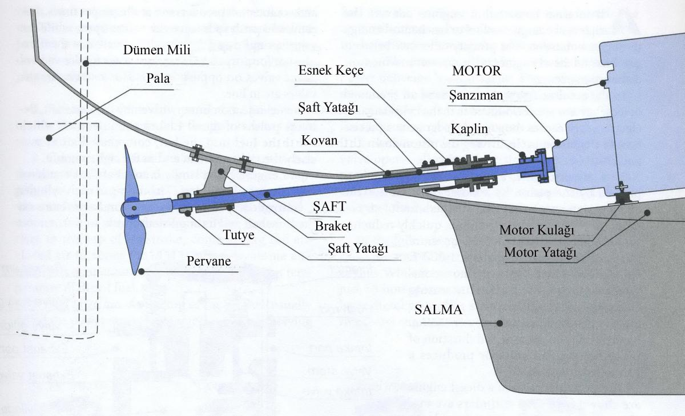
Figure 1.1 The first letters of the figure titles should be capitalized and the other letters should be lowercase. It should be centered under the figure
This graduation project encompasses an engineering-based research study aimed at improving the efficiency of marine propellers. In the field of naval architecture and marine engineering, propeller design holds a significant place in achieving energy savings, reducing operating costs, and minimizing environmental impacts. In this context, developing more efficient, economical, and sustainable solutions has become a major necessity today. Within the scope of the study, different propeller types and geometries were analyzed to examine their effects on performance. Using numerical analysis methods, flow simulations (CFD), and related engineering calculations, propeller design parameters that provide higher efficiency were identified. The findings obtained contribute to the academic literature and provide valuable insights for industrial applications. This graduation project represents a study in which the theoretical knowledge acquired during undergraduate education is reinforced through practical engineering applications, providing an opportunity to develop research and analytical skills. One of the main objectives has been to contribute to sustainable developments in marine engineering and maritime technologies. The technical details of the general propeller system and shaft arrangement used in the study are presented in Figure 1.1 and Figure 1.2. The propeller efficiency (η) formula used for marine propellers and general propeller systems is given in Equation 1.1 Propeller Efficiency (η) Formula.
$$η=\frac{T.V}{2πnQ}$$ | (1.1)
This graduation project study covers engineering-based research carried out to increase the efficiency of ship propellers. In the field of naval architecture and marine engineering, propeller design has an important place in order to save energy, reduce operating costs and reduce environmental impacts.

Figure 1.2 If you want the shapes you add to appear when you use the update table command to the shape table, you need to select the shape caption style as "Caption".
- CHAPTER HEADING

2.1 Sub-Title
This graduation project study covers an engineering-based research carried out to increase the efficiency of ship propellers. In the field of naval architecture and marine engineering, propeller design has an important place in order to save energy, reduce operating costs and reduce environmental impacts. In this context, it has become a great necessity to produce more efficient, economical and sustainable solutions.
Within the scope of the study, different propeller types and geometries were analyzed and their effects on performance were examined. By using numerical analysis methods, flow simulations (CFD) and related engineering calculations, propeller design parameters that will provide higher efficiency have been revealed. The findings both contribute to the academic literature and shed light on sectoral practices.
This graduation project is a study in which the theoretical knowledge acquired during undergraduate education is reinforced with practical engineering applications and allows the development of research and analysis skills. One of the main goals has been to contribute to sustainable developments in the field of ship machinery and marine technologies.

- COST ANALYSIS

3.1 Sub-Title
Students taking Yacht Design, Ship Design, Marine Engine Design, and Marine Auxiliary Machinery Design Project courses are required to include a Cost Analysis section.This graduation project study covers an engineering-based research carried out to increase the efficiency of ship propellers. In the field of naval architecture and marine engineering, propeller design has an important place in order to save energy, reduce operating costs and reduce environmental impacts. In this context, it has become a great necessity to produce more efficient, economical and sustainable solutions.
Within the scope of the study, different propeller types and geometries were analyzed and their effects on performance were examined. By using numerical analysis methods, flow simulations (CFD) and related engineering calculations, propeller design parameters that will provide higher efficiency have been revealed. The findings both contribute to the academic literature and shed light on sectoral practices.
This graduation project is a study in which the theoretical knowledge acquired during undergraduate education is reinforced with practical engineering applications and allows the development of research and analysis skills. One of the main goals has been to contribute to sustainable developments in the field of ship machinery and marine technologies.
- CONCLUSION

Conclusion
The conclusion section should include an overall evaluation of your work. It should include the following elements:
- Summarizing the main findings of the study.
- Evaluation of whether the research has achieved its purpose.
- Explanation of the theoretical or practical contributions of the results obtained.
- Limitations of the study and suggestions for future research.
The conclusion should emphasize the importance of your work and give a clear message to the reader by giving an overall assessment.

REFERENCES

Bibliography should be made using one of the IEEE or APA formats. (If APA style is used, references should be listed in alphabetical order by the authors’ surnames.) (References may be managed using Zotero or Mendeley.)

[1] J. Carlton, Ship Propellers and Propulsion, Butterworth-Heinemann, 2012.
[2] T. L. Saaty, Decision Making by the Process of Analytical Hierarchy, International Journal of Service Sciences, 2008.
[3] ITTC, Expert Committee on Power Performance Estimation, Final Report and Recommendations Submitted to the 27th ITTC, International Towing Tank Conference, 2014.
[4] Y. Kinnas, M. Hsin, Analysis of Flow in Partial Cavitation Hydrofoil Circumference by Boundary Element Method, Journal of Ship Research, 1991.
[5] R. E. Faltinsen, Sea Loads on Ships and Offshore Structures, Cambridge University Press, 1990.
[6] H. Kuiper, Wageningen Propeller Series, International Shipbuilding Progress, 1975.
[7] M. Streckwall, A Numerical Review of Propeller-Hull Interaction, Journal of Ship Technology, 1994.
[8] A. W. Gawn, Propeller Design, Royal Institution of Naval Architects Proceedings, 1952.

A
APPENDIX CHAPTER HEADING

If there is an Appendix, please specify it here. Otherwise, you need to delete this section!!
CURRICULUM VITAE
PERSONAL INFORMATION
PHOTOGRAPH
Name and SURNAME:
Date of birth:

Foreign Language :

Email:

LinkedIn : (If Available)

