Alpha Young Talent Program 2024

Full Time / İstanbul, Bursa, Gebze

Job Description

Borusan Alpha Young Talent Program
Full Time / İstanbul, Bursa, Gebze (Kocaeli)

Are you a fresh graduate willing to act on your own initiative to make a difference and assume full responsibility in your first career experience?
Do you care about adding value not only to business but also to society?
If your answers to the questions above are yes, then Borusan Young Talent Program is the perfect match for you!

Let’s Make It Different in Borusan!
Discover your career journey with Borusan Young Talent Program, where you can take new responsibilities for your personal development and learn to make differences with your ideas and projects to build our future!

About Borusan:

As Borusan Group, with our 80-year history, we are among the established industrial groups in Turkey. We operate in the steel, distribution, logistics, and energy sectors in more than 11 countries across three continents, with over 14,000 colleagues. We continue to achieve steady growth with a focus on innovation, entrepreneurship, and research and development (R&D).
The core strategy of Borusan Group is built upon creating added value for the Turkish economy while maintaining a vision oriented towards developing innovative products and services, with an open outlook to global markets.
Volunteerism and social benefit are significant values for Borusan. Through Borusan Sanat and Borusan Contemporary, operating under the Borusan Kocabıyık Foundation, we make significant investments in music and contemporary art in our country.
With our commitment to contributing to our country, we implement pioneering projects in the fields of education, culture and the arts, and gender equality within the framework of our social responsibility principles.

Being One of the Borusan Team:

Since 1991, through our Borusan Alpha Young Talent Program, which has won international awards from The Peer Awards for Excellence, we are recruiting and developing high-potential recent graduates, contributing to Borusan Group by nurturing the leaders of the future.

We evaluate students who will complete their undergraduate or graduate degrees in the current year's June/July period, applying assessment tools to measure candidates' full potential. After the assessment, we support Alpha Young Talents, who are hired full-time, through a structured 2-year development program on their path to becoming future leaders.
In 2022, we have completed our Borusan Alpha Young Talent recruitments with 41 new talents. We are excited to have the opportunity to welcome you to our team in 2024!
Who Are We Looking For?

- If you are a senior student in university and expect to graduate in 2024 Spring semester or have maximum 1 year of work experience (for those who have more experience, we invite you to apply our other job offerings),

- If you love being challenged and feel enthusiastic about problem solving,

- If you have excellent command of English, both written and spoken,

- If you are an active part of your community (being involved in extra-curricular activities such as volunteer works, internships and other projects is always a plus for our recruitment process),

- Lastly, if you believe in the power of knowledge, experience, and continuous learning; we think that Alpha Young Talent Program is what you’re looking for!
Why Should You Apply?

- You will have the opportunity to proactively take charge and assume full responsibility when you are with us, embracing the learning curve of a fresh career,

- You will have the opportunity to work not only with individuals who possess deep sector knowledge and expertise but also to participate in our mentorship program,

- Throughout the Alpha Young Talent Program, you will be included in a 2-year special training program prepared by the Borusan Academy Team,

- You will have the chance to access a wide range of career opportunities within all Borusan Group companies!

*Alpha Young Talent Program has job openings in Borusan Group companies, Borçelik, Borusan Otomotiv, Borusan Cat, Borusan Holding, Borusan Ventures, Borusan Port, Borusan Lojistik, Borusan Boru, Borusan EnBW Enerji, ParçaPazarı, and Supsan.

**Borçelik, Borusan Boru, and Borusan Port companies’ positions are in Bursa city.

As Borusan Group, we are committed to providing equal opportunity in business life and take steps to foster it. We embrace diversity of background, perspective, culture, and experience.
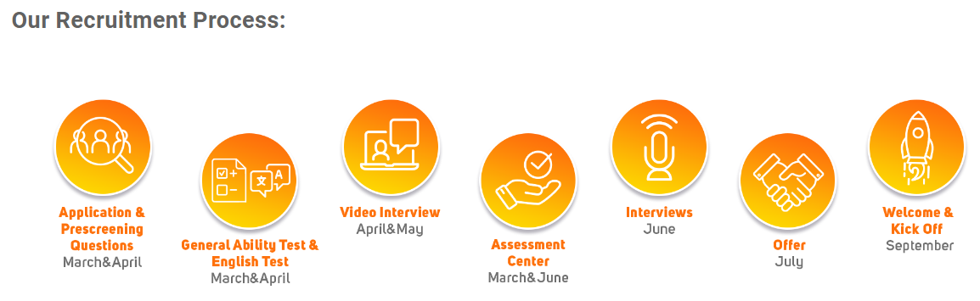

1. Application

2. Online Assessment

3. Lingoby English Test

4. Video Interview

5. Assessment Center

6. HR & Manager Interview

7. Offer
Frequently Asked Questions:

- What is the deadline for Alpha Internship Program application?
March 11, 2024 - Keep up with the latest about our internship program by following our social media accounts!
- How will you contact me?
Please check your email inbox frequently.
- What if I have more questions?

You can reach us via borusanalpha@borusan.com

Position Type
Full Time

Employment Type
Hybrid

